**Helm 2 vs Helm 3 Architecture**

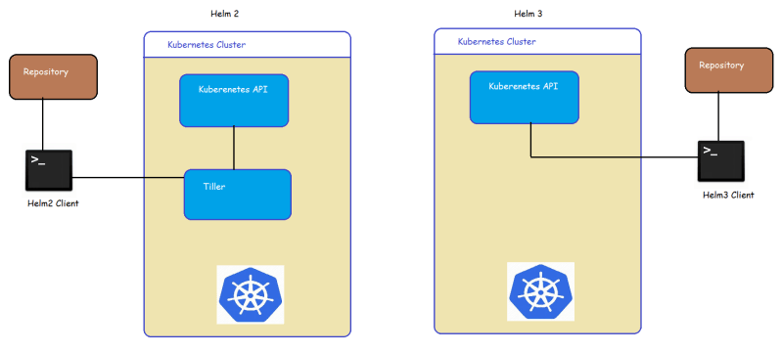

* Helm and k8s work like a client/server application.
* Helm client pushes the resources to the k8s cluster.
* In Helm 2 the server-side depends on the Tiller whereas Helm 3 got rid of Tiller and entirely relies on Kubernetes API
* Helm 3 authenticates and authorizes by taking the credentials kubectl

**Quick YAML Refresher**

* Multi line string

configurations: |

server.port=8443

logging.file.path=/var/log

**Helm Chart Structure**

* When we create a helm chart the directory structure will be as shown below 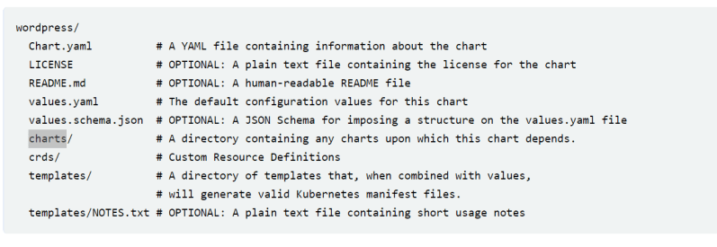
* Now let’s try to understand the purpose of file/directory in the helm charts

| **File/directory** | **Definition** | **Required** |
| --- | --- | --- |
| Chart.yaml | This file contains metadata about Helm chart | Yes |
| templates/ | This directory contains K8s resources in YAML Format | Yes, unless dependencies are declared in Chart.yaml |
| template/NOTES.txt | A file that can be generated to provide usage instructions during chat installtions | No |
| values.yaml | This file contains the charts default values | No, but every chart should contain this file as a best practice |
| .helmignore | A file that consists of list of files and directories that should be ommited from Helm Charts packaging | No |
| charts/ | This directory contains charts that the current Helm Chart depends on | Does not need to be explicitly provided as Helm’s dependency management system will automatically create this directory |
| Chart.lock | A file used to save the previously applied dependency version | Does not need to be explicitly provided as Helm’s dependency management system will automatically create this directory |
| crds/ | A directory that contains Custom Resource Definition YAML resources to be installed before templates | No |
| README.md | A file that contains installation & usage information about Helm Chart | No, but every chart should contain this file as a best practice |
| LICENSE | A file that contains HELM charts LICENSE | No |
| values.schema.json | A file that contains the chart’s value schema in JSON format | No |

* Lets create a dummy chart

helm create --help

helm create helloworld

